XIEGU Radio Data Communication Connection Setup Tutorial

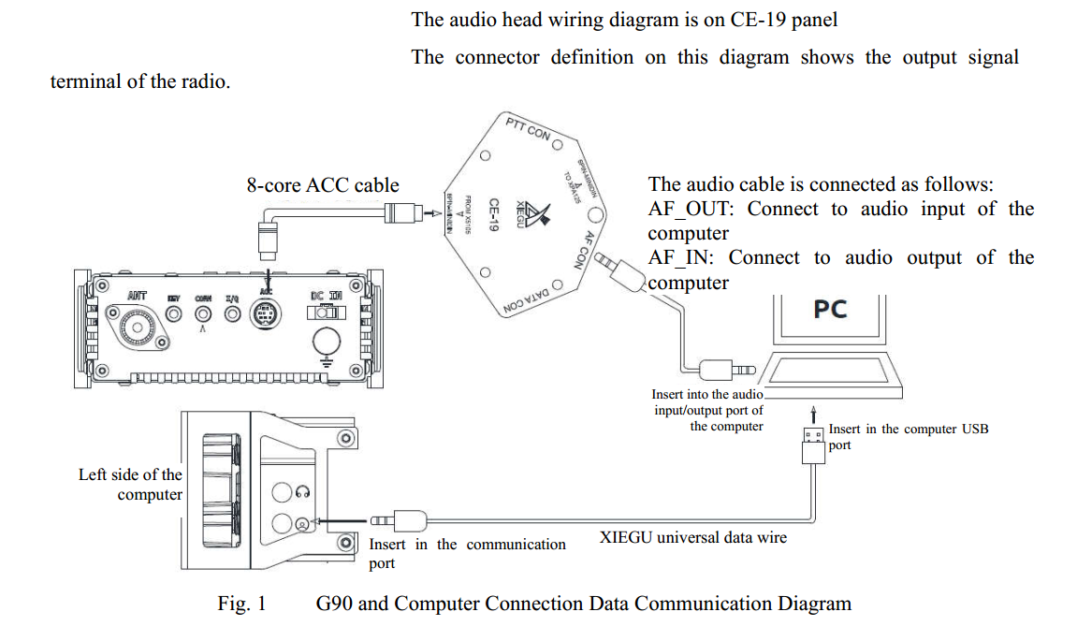

In order to facilitate the use of XIEGU s radio station for data communication, the connection method and settings are explained below, to help for the use.
Applicable models: X5105, G90
This tutorial takes G90 as an example to explain. The X5105 and G90 adopt the XIEGU standard 8-pin ACC interface, so the connection is completely the same.
1、 The principle of amateur radio in data communication:
When amateur radios cooperate with computers to do data communication, the computer is used as a "modem". When receiving, the signal received by the radio is transmitted to the computer for demodulation; when transmitting, the computer-modulated signal is transmitted to the radio for transmission. The relationship is as follows:
Receiving: the radio receives the signal → computer
Transmitting: the computer generates the signal → radio
After figuring out the above relationship, it is not difficult to understand the way the two are wired.
2、 Preparation:
1) XIEGU radio universal data cable (USB-3.5mm plug), and the driver of the data cable which has been correctly installed on the computer.
2) One set of CE-19 expansion cards (required for 8-core ACC cable and audio cable)
3) Several EMC magnetic rings
3、 Wiring steps
3.1 Insert the 3.5mm plug of the universal data cable into the communication port on the left side of the G90 head, and insert the USB into the computer.
3.2 Insert the delivered 8-core ACC cable into the ACC port at the end of the G90 and the other end into the corresponding port on the CE-19 (note that there is only one 8-core port).
3.3 Insert one end of the delivered audio cable into the AF CON interface of the CE-19, and, according to the wiring diagram on the CE-19 panel and connecting method of the audio input/output port of your own computer, connect the other end with a 3.5mm stereo plug, and insert it to the audio port on the computer. As shown in Fig. 1.
3.4 Set G90 to "Line in" mode. For details, see the G90 operation manual.
3.5 Data communication can be performed by setting the G90 to the corresponding working mode.
At this point, the wiring is complete.
The operation method of the PC-side software is not described here.
Tips:
• The communication port of the X5105 is the CIV (COMM) port on the right side, and the ACC port is also on the right side. The wiring method is consistent with the G90.
• The X108G takes a 6-core ACC port and the CE-19 adapter cannot be used. The self-made connection cable can be defined according to the interface on the X108G operation manual. The wiring method is consistent with the G90.
• The EMC magnetic ring on the USB data cable and the audio cable close to the computer end card can eliminate the interference of the RF signal to the USB port, making the connection more stable.

